Project Development Phase
Performance Test
Date | 28 September 2026
Team ID | 6ab221d587602313e82c60c9
Project Name | Import Data using Transform Maps (Spreadsheet)
Maximum Marks | [Maximum Marks]
Model Performance Testing:
Project team shall fill the following information in model performance testing template.
S.No. | Parameter | Screenshot / Values
1. | Data Rendered | Employee spreadsheet (.xlsx) loaded into the Import Set staging table using a Data Source. All rows and columns from the spreadsheet appear in the staging table.  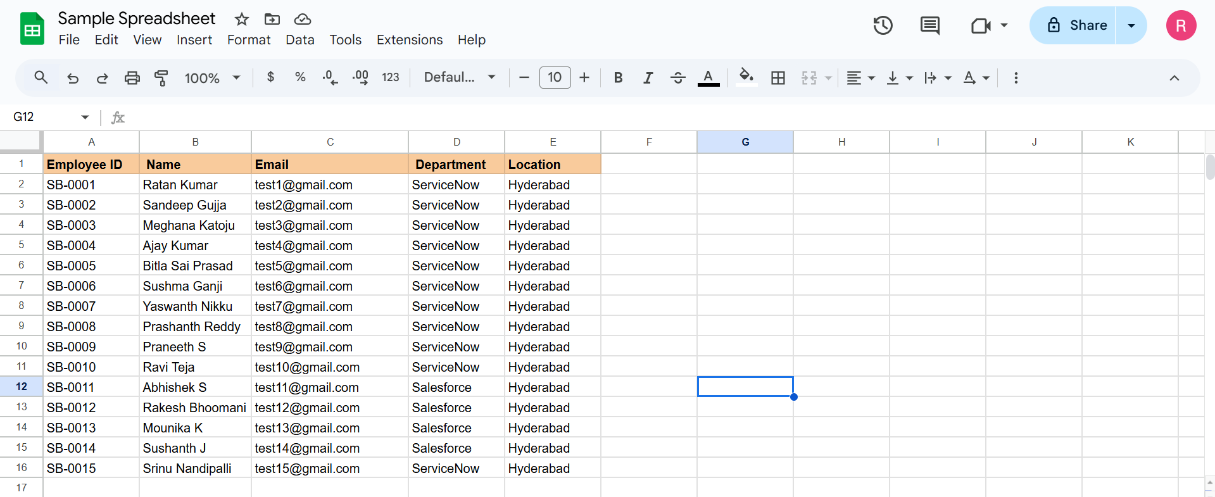  
2. | Data Preprocessing | Empty and invalid rows are skipped with an onBefore transform script. Field values (name, email, date) are cleaned and formatted with field transform scripts before insertion.
3. | Utilization of Filters | Coalesce set on a unique field (Employee ID / Email) to update existing records and avoid duplicates. Transform History filtered by state to review inserted, updated and skipped records.    
4. | Calculation fields Used | Field transform scripts used as calculated fields: date format conversion and name/email formatting.
5. | Dashboard design | No of Visualizations / Graphs - 0  Not applicable: this project focuses on data import. Import results are reviewed in Transform History.  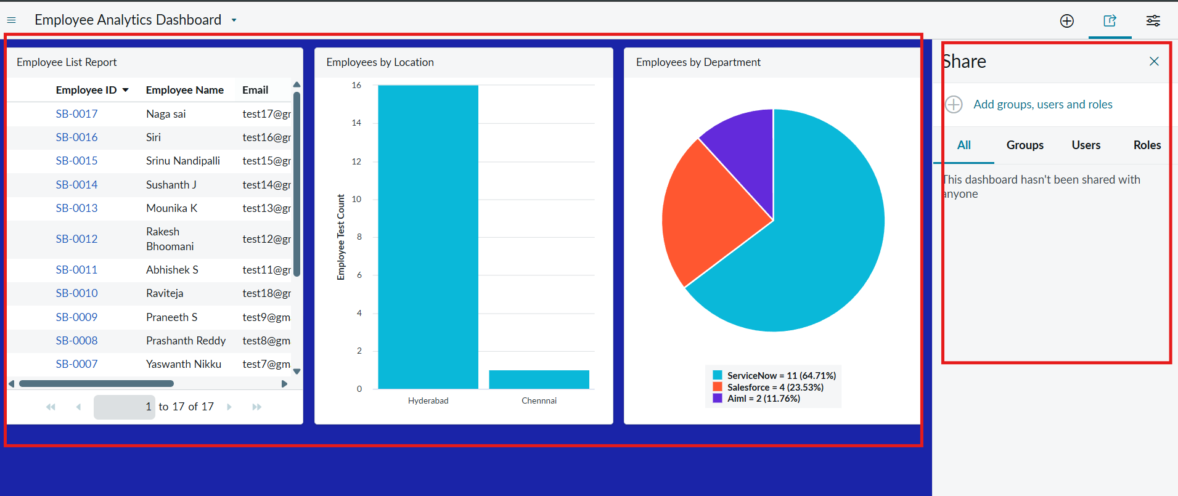
6. | Story Design | No of Visualizations / Graphs - 0  Not applicable: this project focuses on data import.

